The 31st Symposium on Phase Change Oriented Science
PCOS 2019

PCOS web site http://www.jpcos.jp/

November 28 (Thurs.)- 29 (Fri.), 2019

Conference site and Accommodation : KKR Hotel Atami
Address : Kasuga-cho 7-39, Atami, Shizuoka, 413-0005 Japan
URL: https://www.kkr-atami.gr.jp/
Tel : +81-558-85-2000

Managed and Sponsored by The Society of Phase Change Oriented Science

Scope and the history of this Symposium
The Symposium on Phase Change Oriented Science (PCOS) (predecessor: The Symposium on Phase Change Optical Information Storage), will welcome its 31st meeting this year. The Symposium provides the attendee the opportunity to collectively discuss advances in phase change technology every year, with topic including optical discs, phase change memory (PRAM or PCRAM), and other applications using phase change materials and/or phenomena. It also covers fundamental research on phase change materials (chalcogenides, oxides, etc.) including crystallization mechanisms, the local structure, electrical, optical, or magnetic properties, and related topics. Recently, the conference has welcomed studies on thermal properties as well, including thermophysical properties, thermoelectric materials, thermal management, and phonon engineering.
The Symposium serves as a forum to discuss basic and applied phase change technology and science. The organizers would like to enliven this Symposium with active discussions and exhibitions of phase change material related devices to offer a productive venue for the exchange of information.

Topics to be Considered
This Symposium provides a forum for the scientific and industrial communities to exchange information on phase change phenomena, the status of phase change devices, system and applications. Discussions will cover a broad range of topics from basic theory to manufacturing issues.

- Basic Theory
Phase change phenomena
Analysis of crystallization and amorphization
Structural analysis
Electronic structures
- Optical Discs
Rewritable and write once discs
Characterization, recording, readout mechanisms
Super-resolution
Multi layer recording
- Non-Volatile Memory Application
Phase change materials
Device structure
Ovonic threshold switching device
- Novel Applications
New devices using phase-change technology
Meta-materials
- Thermal Properties
Thermophysical properties
Thermoelectric materials
Phonon engineering

Schedule of Events (tentative)
Thursday 28 November 2019
12:00-13:00 Registration
13:00-16:20 Oral Session
16:20-17:50 Poster Session
19:00- Banquet
Friday 29 November 2019
9:00-16:00 Oral Session
16:00- Award and Closing

Advisory Committee
Kunimaro Tanaka, Teikyo Heisei University
Takahiro Kubo, Kubo Technical office
Kazunori Ito, Ricoh Company Ltd.
Toshihiro Sugaya, The University of Electro-Communications
Ryuuji Sato, Japan Broadcasting Corp.( NHK)
Takeo Ohta, Ovonic Phase Change Institute
Isao Satoh, i&H Consulting Company

Technical Program Committee
Noboru Yamada, General Chair
Toshimichi Shintani, Hitachi LG Data Storage Co., Chair
Keiichiro Yusu, Mitsui Interbusiness Research Institute
Masashi Kuwahara, National Institute of Advanced Industrial Science and Technology
Hajime Yuzurihara, Nanotechnology Business Creation Initiative
Rie Endo, Tokyo Institute of Technology
Toshiharu Saiki, Keio University
Yuji Sutou, Tohoku University
Takashi Yagi, National Institute of Advanced Industrial Science and Technology
Yuta Saito, National Institute of Advanced Industrial Science and Technology
Muneaki Hase, University of Tsukuba

Symposium Secretary
1) Application of attendance and Accommodation
Yuta Saito
Nanoelectronics Research Institute
National Institute of Advanced Industrial Science and Technology
E-mail: yuta-saito@aist.go.jp

2) Editing of Abstract and Proceeding
Toshiharu Saiki (PCOS2019 Editor)
Department of Electronics and Electrical Engineering
Keio University
E-mail: saiki@elec.keio.ac.jp

Preparation of Abstract
The presenter is requested to submit a one-page abstract of A4-size. A table or figure may be optionally included. A template file can be downloaded from the PCOS website. All contributed papers reporting on original work that fall within the scope of the Symposium will be accepted as Oral presentations. If more abstracts are received than the number of Oral presentation slots, the organizers will request some authors to switch from Oral to the Poster presentations. The scientific program will be determined by program committee around September, after which the final program will be posted on the PCOS website.
Abstracts must be received by 23rd August, 2019.

Submission of Abstracts
Toshiharu Saiki (PCOS2019 Editor)
Department of Electronics and Electrical Engineering
Keio University
E-mail: saiki@elec.keio.ac.jp

Submission of Paper
Details of paper submission will be individually reported to each presenter after acceptance of an abstract. The deadline for paper submission is 27th September, 2019.

Oral Presentation
The language should be Japanese or English. In general, presentation time is 25 minutes, including five minutes for discussion. Papers designated as “Special” are given 40 minutes presentation time, including 5 minutes for discussion.

Audio-Visual Aids
We would like to ask presenters to bring their own laptop PCs as well as appropriate adapters for the projector (it is not currently known which type, RGB or HDMI, of adaptor will be available in the meeting room, so we encourage presenters to bring both types). We will provide a screen, projector, microphone, and laser-pointer. Please let us know, if you cannot bring a laptop PC and/or you need other equipment.

Poster Presentation
All poster presenters must display their posters during Registration on the first day. The positions of each poster will be indicated on the poster board. Authors are asked to stand by their posters during the Poster Sessions on the first day, and are encouraged to discuss the contents with as many attendees as possible. We propose using the A0 format for your poster (Width:84 cm × Hight:119 cm, portrait format).

PCOS Award
The PCOS Award was established in 2002. After all sessions are complete, the Best Oral and Poster presentations will be awarded based on the voting by all organizes and attendees.

Registration Fees
Type |  | Fee
A | Regular  Student | \45,000  \32,000
B | Regular  Student | \35,000  \22,000
C | Regular  Student | \20,000  \10,000
Type A: One copy of Technical Digest, 2 nights. (27th, 28th Nov.)
Type B: One copy of Technical Digest, 1 night. (28th Nov.)
Type C: One copy of Technical Digest
Note: Please submit a Registration Form at the last page.

You may pay registration fees either by bank transfer or by cash at the registration desk during PCOS2019. For bank transfer, please see the Japanese flyer for more detail.
Please note that we don’t accept credit cards.

Deadline for registration: 1st November, 2019

Travel Information

Tokyo Station – Atami Station (Shinkansen: 50 min.)
Nagoya Station – Atami Station (Shinkansen: 120 min.)
Osaka Station – Atami Station (Shinkansen: 180 min.)

Atami Station – KKR Hotel Atami (Walking: 7 min.)
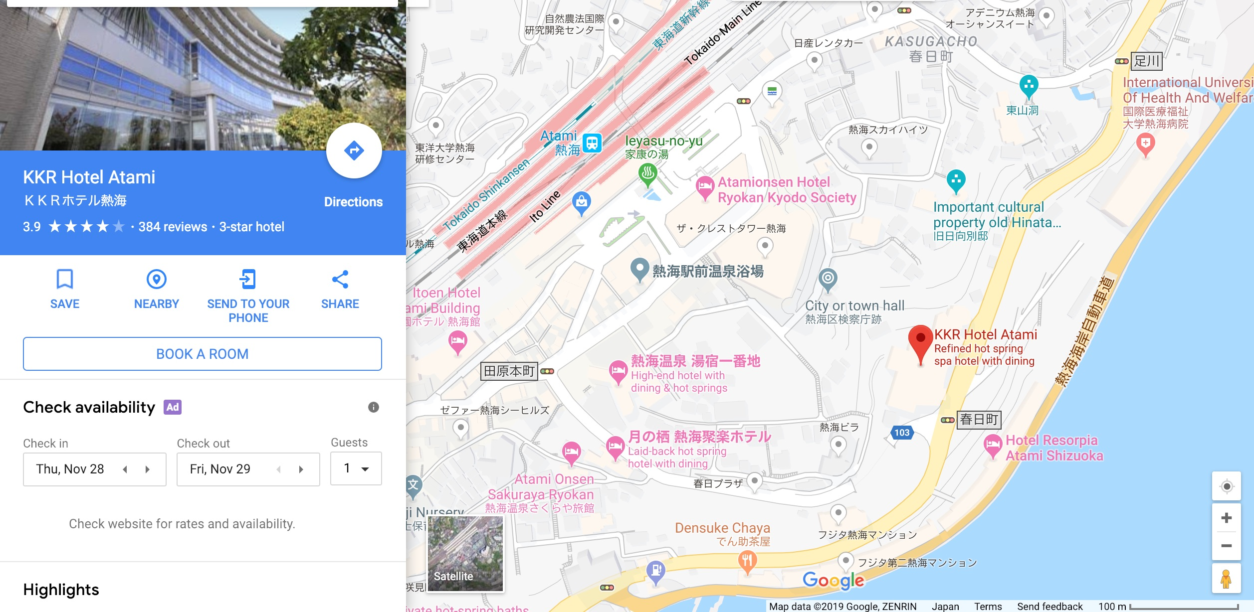
See a map below for the venue place as well as the station.

Contact information of the Symposium Secretary

Yuta Saito
Nanoelectronics Research Institute
National Institute of Advanced Industrial Science and Technology
E-mail: yuta-saito@aist.go.jp

Registration Form for
31st Symposium on Phase Change Oriented Science
PCOS 2019

Last Name: 1st Name: E-mail: Type:

Last Name: 1st Name: E-mail: Type:

Last Name: 1st Name: E-mail: Type:

Last Name: 1st Name: E-mail: Type:

Organization:

TEL/FAX:

Address: Country:

Registration Fees

Type |  | Fee
A | Regular  Student | \45,000  \32,000
B | Regular  Student | \35,000  \22,000
C | Regular  Student | \20,000  \10,000
Type A: One copy of Technical Digest, 2 nights. (27th, 28th Nov.)
Type B: One copy of Technical Digest, 1 night. (28th Nov.)
Type C: One copy of Technical Digest
You may pay registration fees either by bank transfer or by cash at the registration desk during PCOS2019. For bank transfer, please see the Japanese flyer for more detail. Please note that we don’t accept credit cards.

Deadline for registration : 1st November, 2019

